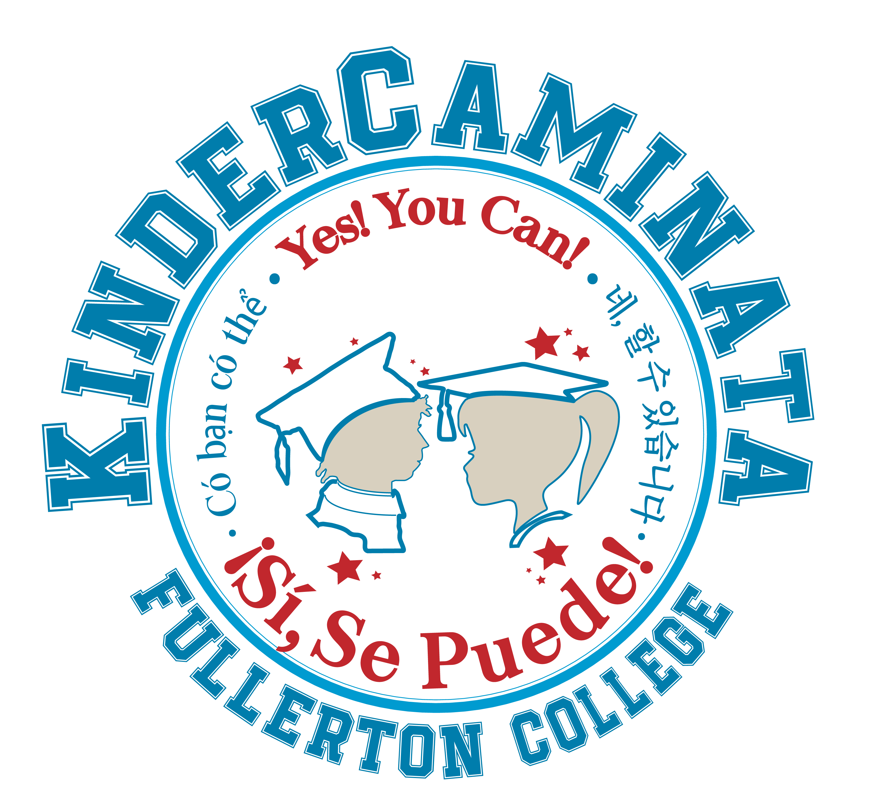
ACTIVITY STATION INFORMATION

On Friday, March 6th over 1,500 children, teachers, and parents from Fullerton, Anaheim City & La Habra School Districts will visit Fullerton College to learn about college and explore the many careers available to them in the future.
Logistics –

Before the Event
Student Volunteer Registration – two options
- Student volunteers should register at http://www.socsci.fullcoll.edu/kindercaminata. This will ensure we can provide email updates, provide certificates for volunteer hours, and document the number of students who participated.
- Email a list of student names, email addresses, the name of the activity station they will be working with, and ID numbers to mhafer@fullcoll.edu. I will add them to the online system.
KinderCaminata Day of the Event

7:00 a.m. Volunteer check in begins at 7:00 near the Cafeteria

7:30 a.m. Your room will be unlocked and available for you to set up in by 7:30 a.m. If your station requires a lot of set up please arrive early. Please make a sign with the name of your station.
- Volunteer Check In Check in at the Info Booth.
- T-shirts: T shirts will be at the volunteer check in on the day of the event. Students should come to check in to collect their shirts.
- Certificates will be available at the info booth after the event.
- Breakfast If you and your volunteers arrive early feel free to join us in the cafeteria for a continental breakfast while it lasts.
- Rain Plan – If it is raining the day of the event, we will have an indoor location for every outdoor activity. We will make the call before 7:30 if we need to institute the rain plan.
8:30 a.m. Be prepared for classes to arrive at 8:30am. The majority of the school buses arrive between 8:30 - 8:45 a.m. They are greeted by KinderCaminata Volunteer Tour Guides that will bring each class to each activity. Encourage your college students to interact and mingle with the children, asking them questions and talking to them about their own college experience.
8:30 a.m. to 11:00 a.m Activity station up and running. When the classes arrive to your station there will be a Kindergarten teacher, parent &/or adult chaperones and a KinderCaminata volunteer tour guide with each class. Introduce yourself to the children, parents and teachers. Plan the activity to cycle classes every 20 minutes. During the 2.5 hour career-station visit time, you can expect approximately 5 – 8 tour groups to visit.
You should not have to deal with any student discipline problems or inappropriate behavior by children – that is the job of the Kindergarten teacher. If you have any children that are acting out or causing a distraction please talk to the Kindergarten teacher and let them handle the situation.
Be aware:
No food of any kind can be given to the children.
Avoid “take homes”, students will not have bags to carry things with them.
No Fullerton College volunteer should be alone with a child in a closed room. That includes the bathroom. Our volunteers can walk with the Kindergarten teacher or parent and child to show them where the restrooms are located but should stay outside.
11:00 a.m. Keep an eye on the clock and close the career station promptly at 11:00am! Please clean up the classroom or area afterwards. Don’t forget your personal items and materials.
It’s important to end at 11:00am so that tour groups go to the Quad on time for final activities and get to their school buses on time. There will be a grand welcome in the Quad, cheers from the classes and guest speakers! Catch a glimpse of all the activity.
All the district classes should be headed back to their bus pick-up location by 11:30am. Be sure that you leave the classroom or quad area clean and tidy.
12:00 p.m. Campus clean up and Certificates of Appreciation will be distributed to all volunteers at the Info Booth. Any certificates not picked up after the event will be available in Room 1300-01.
After KinderCaminata
The Activity Station Committee will send all faculty and student club career station hosts an online evaluation survey to complete. Your feedback is important. Please complete the 5 minute survey to help us make next year even better.
Children will have reflection activities in their classes after the event to reinforce their learning and experiences.

Thank you for making a positive difference in the lives of children and families!

For more information please go to the KinderCaminata website: http://www.socsci.fullcoll.edu/kindercaminata

